# CS 255 System Design Document Template

This template lays out all the different sections that you need to complete for Project Two. Each section has guidance to prompt your thinking. You will need to continually reference the interview transcript as you work to make sure that you are addressing your client’s needs. There is no required length for the final document. Instead the goal is to complete each section based on what your client’s needs are. Remove this note when you are finished, and replace all bracketed text with the relevant information.

## UML Diagrams

### UML Use Case Diagram

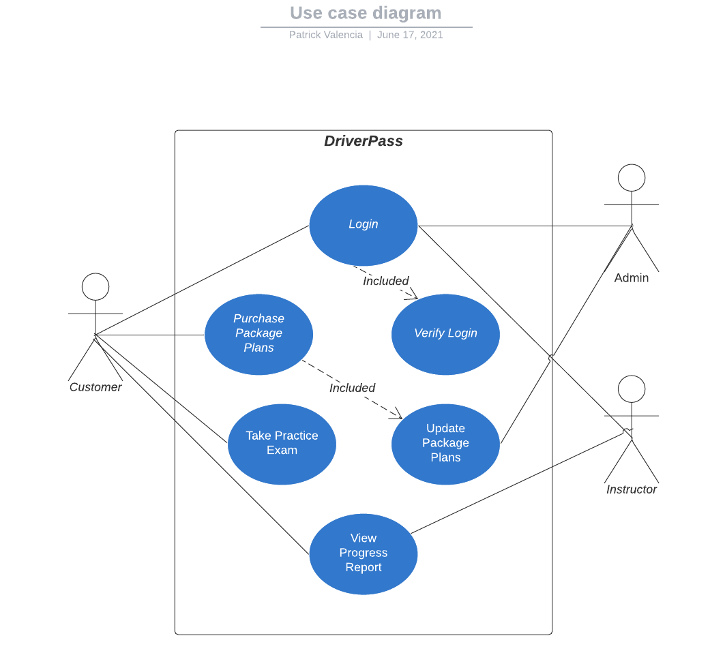

### UML Activity Diagrams

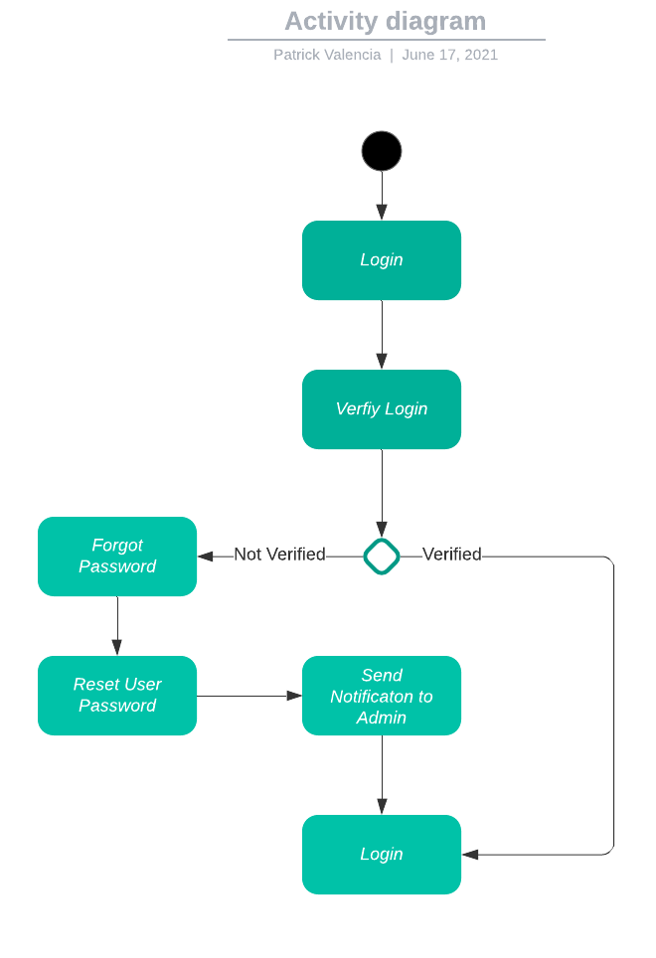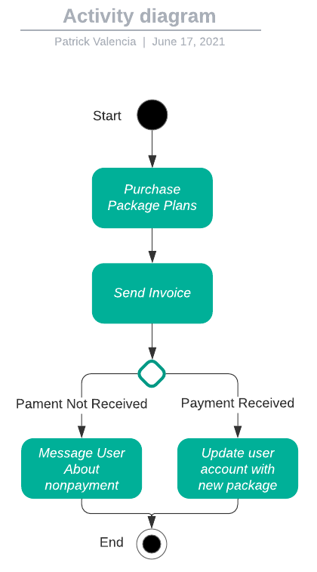

### UML Sequence Diagram

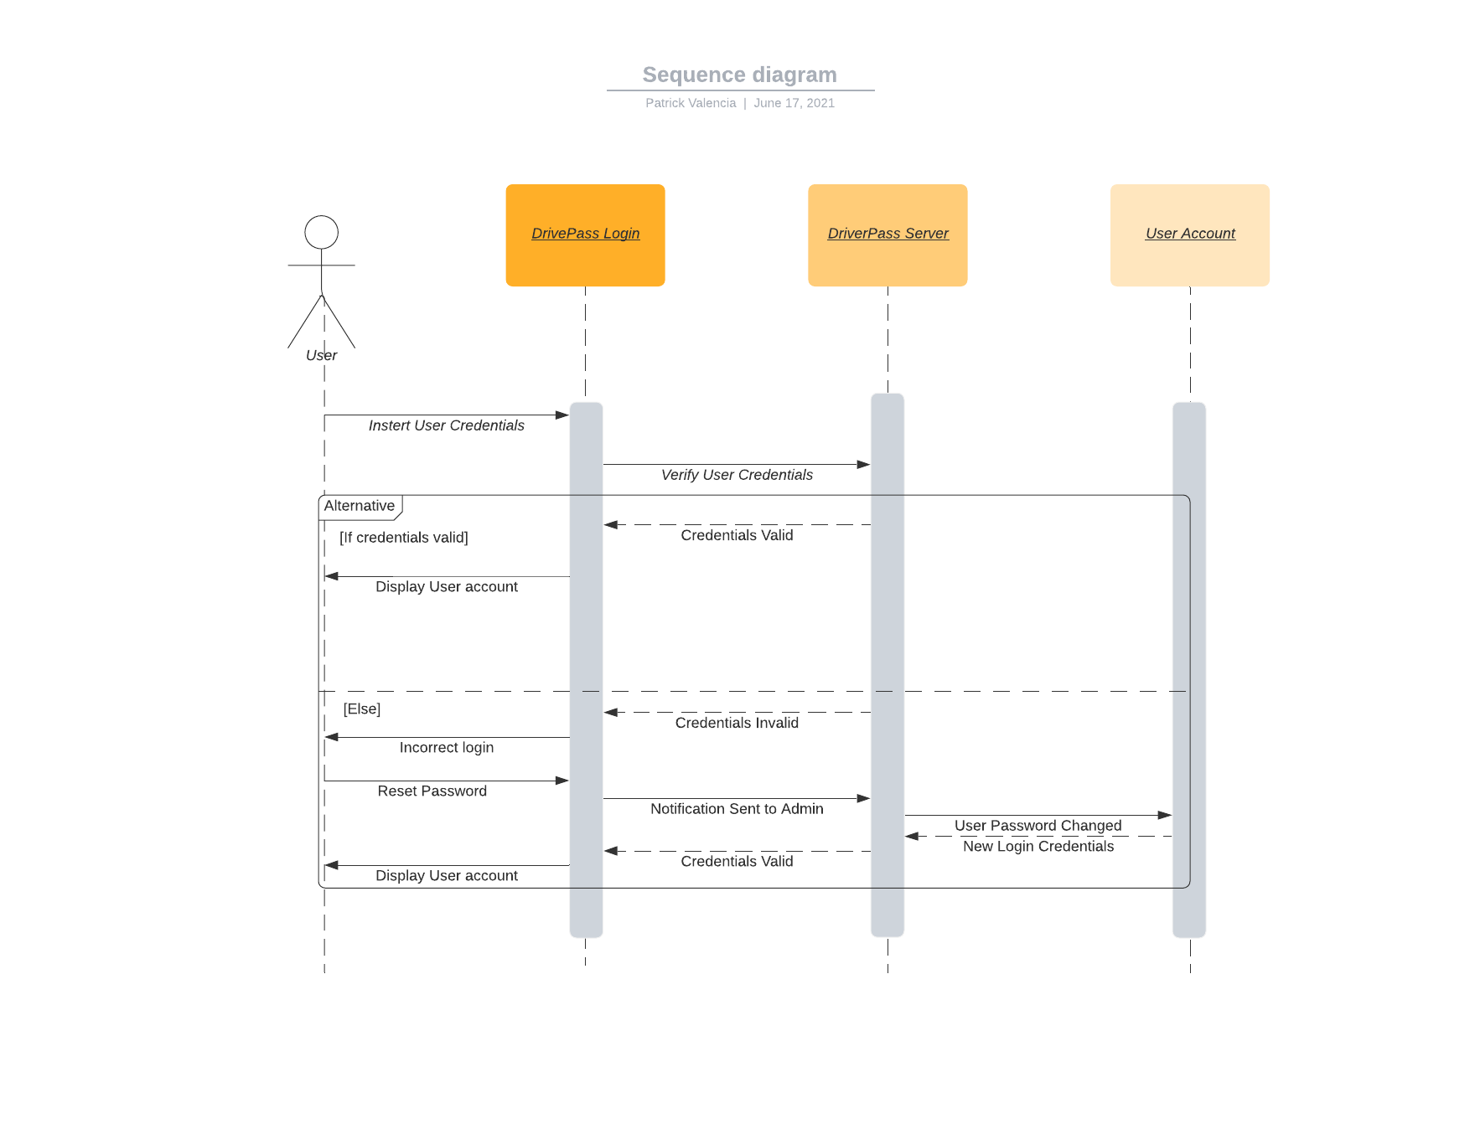

### UML Class Diagram

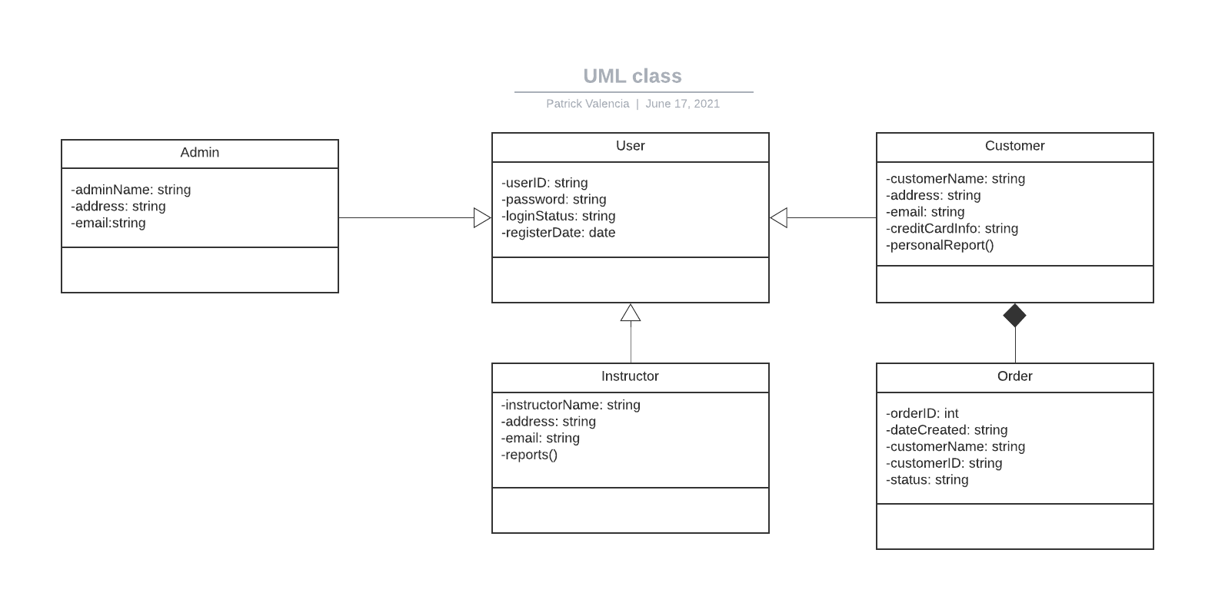

## Technical Requirements

The technical requirements for this system would be minimal on the end users side due to the minimal resources required to run the web based application. This would also apply towards the app based DrivePass due to the way the system is designed to efficiently use resources. The system would be designed to try and keep as many sources web based to limit the amount of storage taken up on customers devices and any sort of animations would be kept to a minimum to help those whose devices have minimal amount of RAM. As for software requirements, the only main one would be some sort of scheduling software due to many IDEs being incredibly intuitive and free to use. The scheduling software would be incredibly helpful in organizing and dividing the work among the development team. For one major piece of hardware DrivePass would need to beef up their server for the increased traffic towards their service as well as from the applications.